H.T No
Regulations:
A18

Sreenidhi Institute of Science and Technology
(An Autonomous Institution)
Code No:7AC07 Date: 17-August-2024 (FN)

B.Tech II-Year II- Semester External Examination, August - 2024 (Supplementary)
CONTROL SYSTEMS (EEE)

Time: 3 Hours Max.Marks:70

Note: a) No additional answer sheets will be provided.
b) All sub-parts of a question must be answered at one place only, otherwise it will not be valued.
c) Missing data can be assumed suitably.

Bloom's Cognitive Levels of Learning (BCLL)

Remember | L1 | Apply | L3 | Evaluate | L5
Understand | L2 | Analyze | L4 | Create | L6

Part - A Max.Marks:20
Answer all QUESTIONS

 |  | BCLL | CO(s) | Marks
1 | Write the torque balance equation of an ideal rotational mass element. | L1 | CO1 | [2M]
2 | Define rise time. | L2 | CO2 | [2M]
3 | State the limitations of Routh stability criterion? | L3 | CO3 | [2M]
4 | What are the advantages of frequency response analysis? | L1 | CO4 | [2M]
5 | Write the transfer function of lag compensator and draw its pole zero plot? | L3 | CO5 | [2M]
6 | What is meant by state transition matrix and give it’s significance? | L4 | CO6 | [2M]
7 | List out various terms used in signal flow graph. | L2 | CO1 | [2M]
8 | What is root locus? | L1 | CO3 | [2M]
9 | When maximum phase lead occurs in lead compensator? Give the expression for maximum lead angle and the corresponding frequency? | L4 | CO5 | [2M]
10 | The damping ratio and natural frequency of oscillation of a second order system is 0.5 and 8 rad/sec respectively. Calculate the resonance peak and resonant frequency? | L5 | CO6 | [2M]
Part – B Max.Marks:50
ANSWER ANY FIVE QUESTIONS. EACH QUESTION CARRIES 10 MARKS.

 |  |  | BCLL | CO(s) | Marks
11. | a) | Write the differential equations governing the mechanical system.  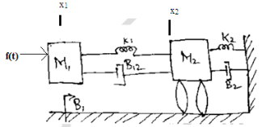 | L3 | CO1 | [5M]
 | b) | Determine the overall transfer function C(S)/R(S) for the system shown in figure using block diagram reduction technique?  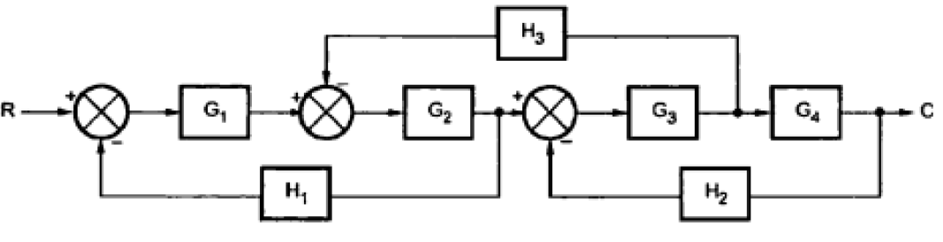 | L4 | CO1 | [5M]
12. | a) | A unity feedback control system is characterized by the open loop transfer function 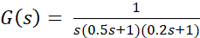. Determine steady state error for unit-step and unit ramp inputs. | L3 | CO2 | [5M]
 | b) | With the block diagram explain the concepts of PI and PD compensation. | L4 | CO2 | [5M]
13. | a) | By means of Routh criterion, determine the stability of the following characteristic equation  . | L3 | CO3 | [5M]
 | b) | Draw the rough sketch of root locus and comment on stability of an open loop transfer function 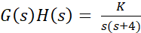. | L4 | CO3 | [5M]
14. | a) | Sketch the bode plot for the following transfer function 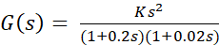 | L5 | CO4 | [5M]
 | b) | Determine the system gain K for the gain cross over frequency to be 5 rad/sec. | L5 | CO4 | [5M]
15. | a) | Explain the lag-lead compensator network and briefly discuss the effects of lag-lead compensator? | L4 | CO5 | [5M]
 | b) | Using Nyquist stability criterion, find the closed loop stability a negative feedback system whose open loop transfer function is given by 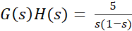. | L5 | CO5 | [5M]
16. | a) | A linear time invariant system is characterised by the homogeneous state equation: 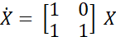.  Compute the solution of homogeneous equation, assume the initial state vector 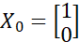. | L3 | CO6 | [5M]
 | b) | Obtain the solution of non-homogeneous state equation by using Laplace transform method. | L2 | CO6 | [5M]
17. | a) | Distinguish between the open loop and closed loop systems. | L1 | CO1 | [4M]
 | b) | A unity feedback control system has an open loop transfer function 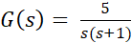. Find the peak time and settling time. | L3 | CO2 | [3M]
 | c) | Determine the range of K for stability of unity feedback system whose open loop transfer function is 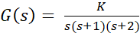. | L5 | CO3 | [3M]
18. | a) | Define gain margin and phase margin. Explain how these can be determined using bode plot? | L2 | CO4 | [4M]
 | b) | Draw the polar plot for the transfer function given by 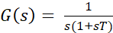. | L3 | CO5 | [3M]
 | c) | List out the properties of state transition matrix. | L1 | CO6 | [3M]
-- 00 -- 00 –

